**Project Design Phase-II**

**Data Flow Diagram & User Stories**

|  |  |
| --- | --- |
| Date | 15 April 2025 |
| Team ID | SWTID1743947156 |
| Project Name | Expense-Tracker FullStack |
| Maximum Marks | 4 Marks |

**Data Flow Diagrams:**

A Data Flow Diagram (DFD) is a traditional visual representation of the information flows within a system. A neat and clear DFD can depict the right amount of the system requirement graphically. It shows how data enters and leaves the system, what changes the information, and where data is stored.

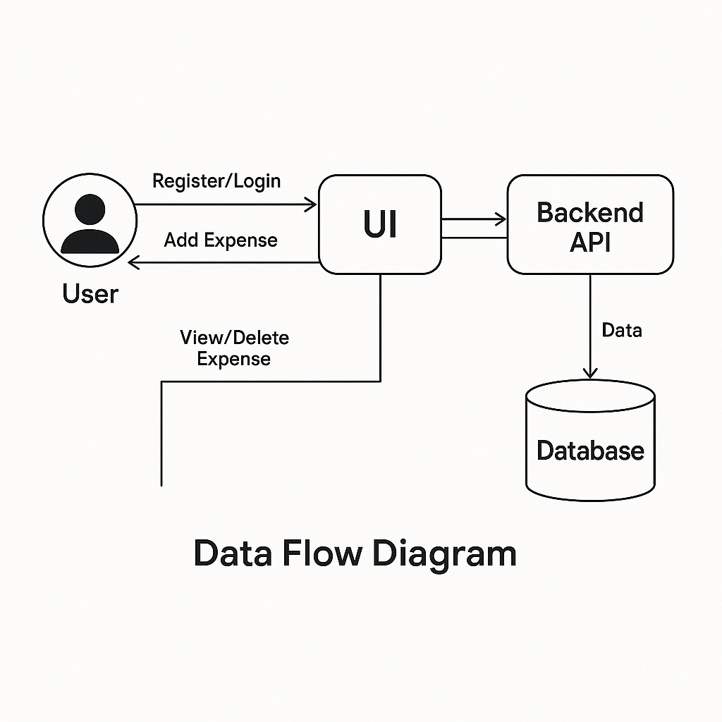

**User Stories**

Use the below template to list all the user stories for the product.

| **User Type** | **Functional Requirement (Epic)** | **User Story Number** | **User Story / Task** | **Acceptance criteria** | **Priority** | **Release** |
| --- | --- | --- | --- | --- | --- | --- |
| Customer (Mobile user) | Registration | USN-1 | |  | | --- | | Register |  |  | | --- | |  | | |  | | --- | |  |   User can register and land on dashboard | High | Sprint-1 |
|  | Registration | |  | | --- | | USN-2 |  |  | | --- | |  | | |  | | --- | | Email Conf |  |  | | --- | |  | | User receives confirmation email | High | Sprint-1 |
|  | Login | |  | | --- | | USN-5 |  |  | | --- | |  | | Login | User can login using credentials | |  | | --- | | High |  |  | | --- | |  | | Sprint-1 |
|  | |  | | --- | | Dashboard |  |  | | --- | |  | | |  | | --- | | USN-6 |  |  | | --- | |  | | |  | | --- | | View Dash |  |  | | --- | |  | | Dashboard shows expense overview | High | Sprint-1 |
|  | |  | | --- | | Add Expense |  |  | | --- | |  | | |  | | --- | | USN-7 |  |  | | --- | |  | | |  | | --- | | Add Exp |  |  | | --- | |  | | User can add categorized expense | High | |  | | --- | | Sprint-1 |  |  | | --- | |  | |
| Customer (Web user) | |  | | --- | | Edit/Delete |  |  | | --- | |  | | |  | | --- | | USN-8 |  |  | | --- | |  | | |  | | --- | | Manage Exp |  |  | | --- | |  | | User can modify or delete expenses | |  | | --- | | High |  |  | | --- | |  | | |  | | --- | | Sprint-2 |  |  | | --- | |  | |
| Customer Care Executive | Analytics | |  | | --- | | USN-9 |  |  | | --- | |  | | |  | | --- | | View Chart |  |  | | --- | |  | | User can view charts/graphs of expenses | |  | | --- | | Medium |  |  | | --- | |  | | |  | | --- | | Sprint-2 |  |  | | --- | |  | |
| Administrator | |  | | --- | | Backend |  |  | | --- | |  | | |  | | --- | | USN-10 |  |  | | --- | |  | | |  | | --- | | APIs |  |  | | --- | |  | | Functional backend APIs with validation | |  | | --- | | High |  |  | | --- | |  | | |  | | --- | | Sprint-2 |  |  | | --- | |  | |
|  | |  | | --- | | Deployment |  |  | | --- | |  | | |  | | --- | | USN-11 |  |  | | --- | |  | | |  | | --- | | Deploy App |  |  | | --- | |  | | |  | | --- | | Working deployed app |  |  | | --- | |  | | |  | | --- | | Medium |  |  | | --- | |  | | Sprint-2 |